Module 5: The Chesapeake Bay

Introduction to Estuarine Systems
Estuaries are sheltered areas where freshwater rivers meet the ocean. These areas are also called bays, inlets, harbors, or sounds, depending on various physical criteria, such as shape, size, depth, amount of freshwater input, etc., of the area. Every estuary is unique.
Due to direct input of nutrients from the land and from the tides and due to the rapid rate at which nutrients are recycled within the system, estuaries are among the most productive ecosystems on Earth. In this module, the basic ecology of the Chesapeake Bay estuary will be described as one example of an estuarine system. In addition, alterations in conditions caused by the humans, living near and far, will be described as we look at another invaluable natural ecosystem that is currently experiencing significant changes.

Location of Chesapeake Bay
Chesapeake Bay is the United States' largest estuary. It has some shorelines within the state of Virginia and others within Maryland. Here are some interesting geological facts about the bay:
- There are approximately 11,700 miles of shoreline found on the Chesapeake Bay and its tidal tributaries.
- The bay ranges in width from about 4 miles near Annapolis, Maryland to 30 miles at its widest point, near the mouth of the Potomac River.
- The approximate main channel length of the Chesapeake Bay is 189 miles.
- The approximate area of the bay and its main tributaries is 4,479 square miles.
- There are approximately 150 major rivers and streams in the Chesapeake drainage basin.
- In the area surrounding the bay, there are at least 4 megalopolises Norfolk, VA; Richmond, VA; Washington, D.C.; and Baltimore, MD.
- Source: Chesapeake Bay Program (https://www.chesapeakebay.net/discover/facts)
Chesapeake Bays watershed is found within 6 states plus the District of Columbia. A watershed is the land area from which water, sediments and dissolved substances enter a body of water. Portions of West Virginia, Pennsylvania, New York, Virginia, Maryland, the District of Columbia, and Delaware make up the 64,000 square miles that is found within the Chesapeake Bays watershed.
In order to protect and restore the Chesapeake Bay, it is important for everyone living and working in these 64,000 square miles to understand the concept of a watershed. Once they do, then they will understand that wastewater from a chicken farm in the eastern panhandle of West Virginia can and does affect water quality within the bay and that the entire region may have to make changes to Save the Bay.

Origin of Chesapeake Bay
Approximately 18,000 years ago, there was a substantial ice sheet covering portions of North America and sea level was 200 m below where it is today. The region in which we find Chesapeake Bay now was dry land. The end of that ice age was about 10,000 years ago and, at that time, the glaciers melted rapidly, the meltwater carved out the Chesapeake basin, sea level rose, and Chesapeake Bay was formed.
What is really interesting is that something "big" happened 35 million years ago that influenced the location that Chesapeake Bay would eventually have. From the far reaches of space, a bolide (comet or asteroid), 3-5 kilometers in diameter, swooped through the Earth's atmosphere and blasted an enormous crater into the continental shelf. The crater is now approximately 200 km southeast of Washington, D.C., and is buried 300-500 meters beneath the southern part of Chesapeake Bay and the peninsulas of southeastern Virginia.
- Source: The Chesapeake Bay Bolide Impact: A New View of Coastal Plain Evolution, C. Wylie Poag USGS 1998).
Therefore, it is believed that the long-lasting topographical depression created by the impact determined the location that the bay would have far in the future.
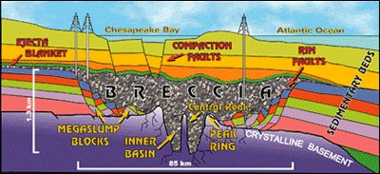
Rock layers affected during crater formation. Image Credit: USGS
Additional Information
(Not Required)
- Additional Information about Chesapeake Bay Geology

Abiotic Factors within the Bay
Estuaries typically have a high diversity of communities within them because abiotic conditions vary significantly on a relatively small spatial scale. In an estuary, freshwater from the rivers meets the saltwater of the ocean; therefore, salinity varies with distance downstream. At the mouth of the estuary (farthest point downstream), the salinity of the water (24 -30ppt) may be very close to that found within the ocean. This of course depends on the amount of fresh water being delivered into the area by the area's rivers. Middle portions of the estuary will have brackish waters and areas far upstream areas may not be influenced by tidal influx at all ( salinity of 0.5ppt). Even at one location, salinity can vary with depth in the water column, because freshwater floats on top of saltwater, which leads to a vertical halocline.
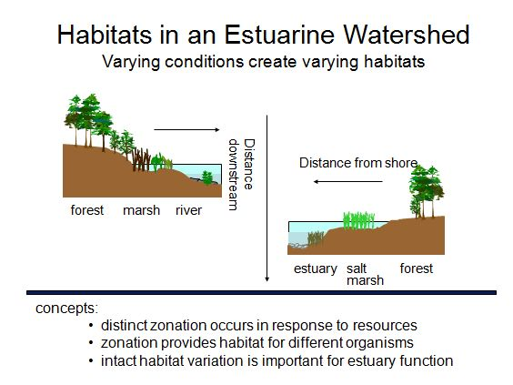
Sunlight availability and dissolved gases also show variation from one area of the estuary to another. While salinity tends to vary from one end of the estuary to another, light availability and gases tend to vary with depth, which changes from shoreline to open water. Sediment type, available resources, and water flow are other abiotic conditions that are highly variable from point to point in estuarine systems.
Not only do conditions vary spatially, in some instances (pun intended) they also vary in one place significantly over short amounts of time. Intense storms or droughts cause changes in water level and salinity, and tides cause water level, at least in some parts of the estuary, to fluctuate daily.
In areas that maintain different abiotic conditions, different habitats occur, and due to this, different species are found in these areas. For example, depending on type of bottom material and salinity, a near shore area might have an oyster reef community or a seagrass bed community. Different communities have their own producers, predators, and scavengers that are adapted to and/or tolerant of the abiotic conditions experienced in that particular part of the estuary.
Therefore, the immense species diversity within Chesapeake Bay (> 3,000 species) is possible because of the high heterogeneity in the environment and is supported by the high primary productivity of the producers of the bay.
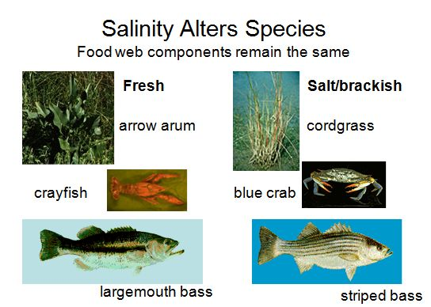

Additional Information
(Optional, but excellent resource. I highly recommend this website because it has so much information on it and it's presented in an accessible way.)
- Additional Information on bay habitats

Food Chain Structure
The examples of producers, consumers, scavengers, and decomposers listed in the diagram are species that would be found largely in the upstream regions of an estuary where the water would either be fresh or salinity would at least be very low. As mentioned in the previous section, the species names will change when you look at different communities, but the positions in the food chain remain similar. In the diagram, different types of producers are listed in the green boxes. Phytoplankton are microscopic algae, emergents are plants that grow partially underwater and partially exposed to air (cord grass), ˜algae in the bottom box refers to filamentous algal forms that grow on the bottom, and SAV stands for ˜submerged aquatic vegetation (seagrasses). The sources of nutrients to the producers include river delivery, ocean water influx with the tides, and the recycling of nutrients that is performed by decomposers living within the community. As in most communities, sunlight supplies the energy that the producers require in order for them to make the food on which the rest of the community relies. The number of arrows only touches on the complexity of trophic interactions that occur within an estuary.
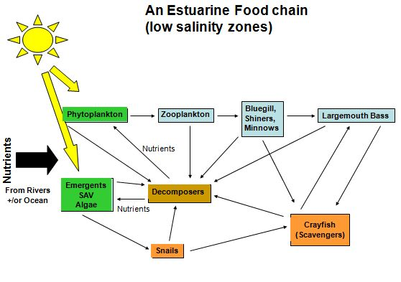

Learning Activity
(Required)
- Put together a diagram that has examples of species that would be found close to the mouth of the bay. You wont have to change many of the specifics of the diagram just the names of the small fish, big fish, and scavengers.

Goods and Services Provided by Estuaries
Stories in John Smith’s journal of the natural wealth he found in a relatively undisturbed Chesapeake Bay amaze us today:
“Of mines (gold or silver) we were all ignorant, but a few beavers, otters, bears, martins, and minks we found. And in diverse places that abundance, of fish lying so thick with their heads above the water [that] as for want of nets (our barge driving among them) we attempted to catch them with a frying pan, but we found it a bad instrument to catch fish with. Neither better fish, more plenty, nor more variety for small fish had any of us ever seen in any place so swimming in the water, but they are not to be caught with frying pans.”
- Source: Captain John Smith, “The Generall Historie of Virginia, New England & the Summer Isles” (1624) http://www.swarthmore.edu/SocSci/bdorsey1/41docs/10-smi.html.
Not only were fish abundant, the supply of oysters and crabs was bountiful as well. Actually, "Chesepiooc" is the Indian name given to the bay, which means “great shellfish waters”. It has been said that before overexploitation and reduced water quality occurred, the oysters in Chesapeake Bay grew to the size of dinner plates. For hundreds of years it was known and fully appreciated that this ecosystem was among the most productive ecosystems in the world – which, of course, is the reason it was densely settled in the early growth of America.
This estuary and others like it provide critical habitat and food for numerous species that spend their entire lives in the estuary, and these systems are also very important to other species that migrate into and out of the bay during their lives. Mature fish may come to the estuary to spawn (lay eggs) among the dense and protective seagrasses or their planktonic larvae may enter the estuary with the tidal flow and get retained; either way, the estuarine habitat protects and “nurtures” young fish until they reach large enough size to successfully move out of the estuary into the ocean. The estuary is essential as well to land dwelling organisms that live in the watershed area and to ones that migrate through or over the ecosystem and rely on the bay for sustenance.
The estuary not only provides food for us to eat, but its decomposers are capable of tremendous waste processing. Rivers within the system transport organic material from the watershed into the bay and the decomposers found there process the wastes into inorganic nutrients for the producers. Additionally, the large amount of sediment and nutrients delivered by the rivers to the bay make the land near the water some of the best farmland in the country.
Physically, the Chesapeake Bay is a large body of water that moderates temperatures in the surrounding area by absorbing and releasing heat, it protects the shoreline from full impact of storm driven waves, and it purifies air and water as exchanges occur between it and the atmosphere. Also, the bay has always been important for trade and transport because boats find inland passageways and shelter within the system.
Chesapeake Bay is an area of great beauty and an area that offers a tremendous number of recreational opportunities. Tourism, property sales, fishing, and farming are important economic components of life in the Chesapeake Bay watershed. But remember, people live in the Chesapeake watershed and the activities of each of them there affect the health of the bay’s organisms and ecological systems.

Threats to Chesapeake Bay - Overview
When the goods and services provided by the bay are considered and its tremendous diversity and functional capacity are explained, it is easy to understand why so many designate the Chesapeake Bay as a national treasure. However, the threats to this ecosystem are complex and diverse. The main threats that will be discussed in this module will be:
- Overharvesting of resources
- Alteration in water quality – causes and consequences
- Climate change
It is the hope of both conservationists and economists that these threats to the bay will be greatly reduced or eliminated completely in the near future, but for that to happen additional ecological studies must be done and appropriate regulations must be continued.

Overharvesting of Resources: Oysters
Crassostrea virginica is called the eastern, American or Atlantic oyster. It is most abundant in the Gulf of Mexico, Chesapeake Bay and Long Island Sound, but its range extends from Canada to South America. The threats that the oyster population in Chesapeake Bay experience are primarily associated with overexploitation, alteration of habitat, and reduction in water quality. In the early to mid 1800's the bay supplied millions of bushels of oysters to oystermen and those oystermen provided a cheap source of protein to the escalating east coast population. By the late 1800's competition for this resource was intense and damage to the oyster bars (reefs) was increasing. In that era, most of the harvesting was undertaken by dredging. Therefore, not only were living organisms being removed in great number (>15 million bushels in 1884), but the oyster's habitat was being severely altered. In 1882 the Oyster Commission was formed to investigate the health of the bay's oyster populations.
In the following link the New York Times reports of the activity of oyster pirates in Chesapeake Bay and the concern regarding over-harvesting of oysters in the year 1888! By 1890, the Oyster Cull Law had been passed that set a minimum size for harvest and required individuals to replace shells on the bars from which they harvested the oysters.
Oyster Pirates in Chesapeake Bay
- The Notorious Oyster Pirates of Chesapeake Bay
This legislation and the laws that followed helped stabilize the oyster population through the mid 1900's, but populations crashed later in that century due primarily to increase in disease occurrence. Two critical oyster diseases, Dermo and MSX, are caused by protozoan parasites. The increase in occurrence of these diseases is positively correlated with the reduction in water quality occurring within the bay. The nutrient load, the organic pollutants, and the increase in temperatures of the water seem to benefit the parasite and to stress the oysters. Today, one of the main goals involved with saving the bay is to reestablish the health of the oyster population. Improving water quality entering the by, rebuilding seagrass beds to help reduce sediments, and providing harvest-free zones in the bay may help the American oyster to rebound but such changes may take years. The University of Maryland has a very successful oyster breeding program that has introduced millions of oyster "spat" -newly settled oysters into the bay. http://hatchery.hpl.umces.edu/
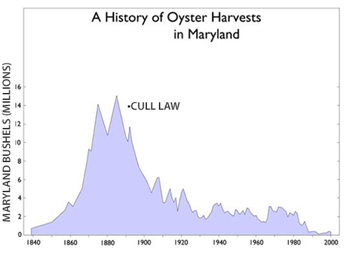
Would introducing a new oyster species help the bay rebound? In the past some individuals were in favor of introducing the Asian Suminoe oyster, Crassostrea ariakensis, into the bay; while others were very fearful of the possible cascading effects that introduced species can have within an ecosystem. The benefits of the Suminoe oyster are that it is a rapid grower, it tastes good, and it's resistant to the parasitic diseases that are limiting the recovery of the American oyster. However, if it is introduced, it could mean the complete loss of the American oyster from Chesapeake Bay and it could spread into other estuaries and coastal locations where Crassostrea virginica is currently holding its own.
In April 2009, the US Army Corps of Engineers and officials from Maryland and Virginia decided against the introduction of the Asian oysters stating that it was "too great a risk to the bay's fragile ecosystem."

Overharvesting of Resources: Striped Bass
The striped bass, Morone saxatilis, also referred to as striper, rockfish, linesider, roller, squidhound, and greenhead, is the most important commercial and recreational fish in in Chesapeake Bay and always has been. The striped bass is found throughout the east coast – from the St. Lawrence River in Canada to the St. John’s River in Florida and in the open waters of the Atlantic Ocean. Some stocks are migratory and move from North Carolina to Nova Scotia and back while others tend to stay within a more limited geographic area. The striped bass is an awesome fish that can weigh close to 100 pounds and grow to nearly 5 feet in length.
After a record harvest of 14.7 million pounds in 1974, the harvest of striped bass fell to 1.7 million pounds in 1983. There was no single cause for the decline in striped bass populations. A combination of resistances starting with the overharvesting that occurred along with detrimental environmental conditions (water temperature, pollution, etc.) has been suggested as the explanation for the population crash. Thousands of jobs and hundreds of millions of dollars were lost from the economy due to the absence of the striped bass from Chesapeake Bay. The population decline was so extensive that the striped bass was listed as a threatened species.
In response to this serious issue, the Atlantic Striped Bass Conservation Act was passed by Congress in 1984. This act was a unique state-based, federally-funded management scheme. It provided federal penalties for violations of any moratorium and afforded $200,000 annually to be split between Maryland and Virginia to be used to stimulate striped bass population growth. From 1985 to 1989, Maryland and Delaware imposed fishing moratoria and Virginia imposed a one-year moratorium in 1989.
By 1995 striped bass numbers had improved to such an extent that it was concluded that the population had been restored. This was extremely good news for fishery management. Currently, the stocks remain under tight regulations and numbers have remained at sufficient levels. Water quality issues are a concern to fisheries managers, but these bass don’t appear to be as sensitive to reduction in water quality as are oysters.
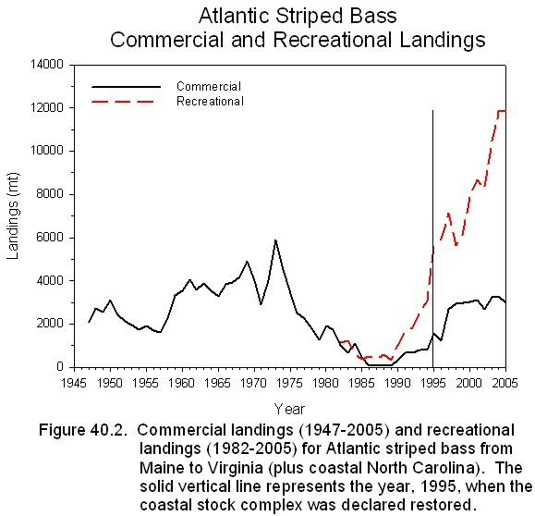

Module 5 Reading Assignment 1
Description:
In addition to oysters and striped bass, the blue crab is also critical to the economic and ecosystem health of the bay. You have two reading assignments for Module 5. This is the first one. A link for the reading is given below along with a set of reading goals that will help define the important issues in the reading. Submissions of answers to the questions are not required.
Instructions:
Click on the link shown below to learn about Chesapeake Bay’s blue crab population.
Click here to read about Chesapeake Bay's blue crab population.
Note: No submission is required for this assignment! These goals are for you to use to guide your analysis and learning from the article.
Reading Goals:
- Review the population information given. Be able to state the changes that occurred between 2019 and 2020.
- The low over wintering mortality of juveniles between 2019 and 2020 is thought to have been due to which physical condition within the bay
- Was the percent of female harvested in 2019 lower or higher than the target percent for sustainable harvesting.

Invasive Species of the Chesapeake Bay
Invasive species often upset the balance found in natural ecosystems, and when that happens, resources can be threatened. In Chesapeake Bay there are many invasive species. Please refer to the following links to get information about the worst of these invaders.
(Required)
- Ten invasive species of the Chesapeake Bay
- Aquatic Invasive Species

Threats to CB: Changes of Water Quality – Causes

Alteration of Water Quality - Causes
Water quality declined in Chesapeake Bay as human population on the watershed increased. Extreme sediment loads, over-abundant inorganic nutrient concentrations, excessive organic matter delivery, presence of toxins and other pollutants, and low amounts of dissolved oxygen are some of the specific ways in which the quality of water has changed in the bay. In this section, the causes of reduced water quality will be examined.
- Loss of marshland
- Agriculture
- Wastewater production and treatment
- Loss of oysters

Alteration of Water Quality:

Due to Loss of Forests and Marshes
Marshland and other wetlands play a critical role in the health of the bay. Even if these lands arent in direct physical contact with the bay waters, they are functionally closely connected to the water quality within the bay. When undisturbed, near shore forests and marshes increase infiltration of water down into the soil and, thereby, protect the bay from rapid changes in water delivery. Without marshes and other wetlands, the bay communities experience stressful alterations in salinity due to surges of freshwater during heavy rain events. During droughts, soil water from intact and healthy near shore forests and marshes slowly enters the bay and prevents drastic increases in salinity from occurring. The marshes also filter the watershed runoff removing excess nutrients, organic matter and even pollutants and toxins before they enter the bay.
Click to enlarge
Photo credit: Mike Dunn
With coastline development, the Chesapeake Bay has lost a great deal of surrounding wetlands. As concrete is poured and lawns are grown, the benefits supplied by the wetlands are lost and water quality within the bay suffers. Man is not the only destructive force when it comes to Chesapeake Bay wetlands. An introduced species called nutria (Myocastor coypus) has done significant damage to preserved wetlands surrounding the bay. Nutria is a large semi-aquatic rodent that feeds on root mats of wetland grasses. The clearing of the wetlands that results from nutria invasions causes erosion and loss of function within these habitats. Also, this rodent has an extremely high reproductive rate and out-competes the native muskrat for habitat and resources

Alteration of Water Quality

Due to Agriculture
A substantial amount of farming and livestock production still occurs in the 64,000 square miles of watershed of the Chesapeake Bay especially in the state of Pennsylvania. Irresponsible agricultural practices hundreds of miles away from the bays shore affect the bays water quality because the water cycle connects one ecosystem with many other ones near and far. Excessive fertilizers (nitrogen especially) and organic wastes (manure, etc.) from farmlands eventually get transported into the bay and alter the water quality and other abiotic and biotic factors change in response.
However, the Chesapeake Bay Foundation actually sees farmland as potentially one of the best uses of watershed acreage if best management practices are implemented. There are many actions farmers can take to prevent excessive drainage of inorganic and organic material from their land. These practices include: precision feeding of livestock that reduces nutrients found in manure, cover crops that hold nutrients in a field between cash crops, rotational grazing that prevents overgrazing that can lead to increased erosion, and riparian buffers between fields and streams that can filter out nutrients before they enter the water. Its important to financially support these activities. One plan in place in Pennsylvania allows farmers that have implemented pollution control tactics on their land to sell pollution credits to developers that need to build sewage treatment plants for their projects.
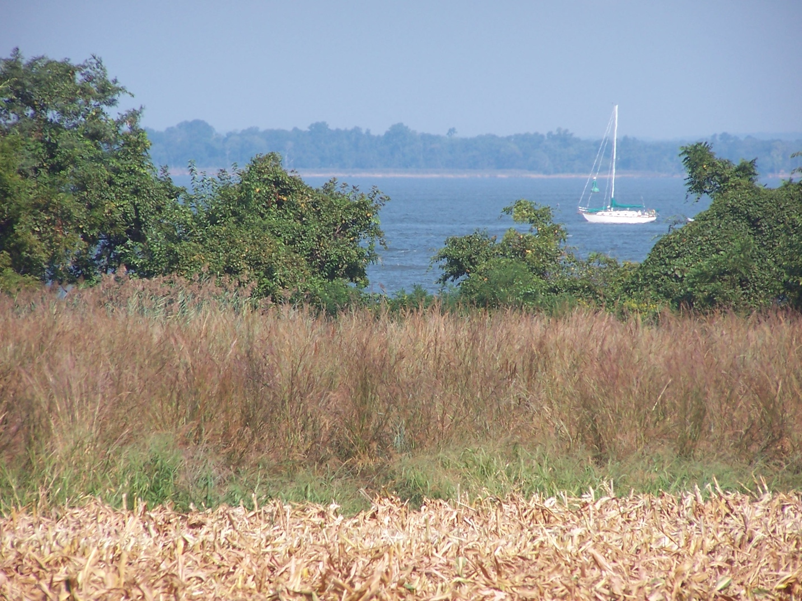
A riparian buffer separates farmland and a river in Maryland. Photo Credit: USDA Farm Service Agency.

Alteration of Water Quality

Due to Wastewater Production and Treatment
For Chesapeake Bay the major sources of excess nutrients are wastewater effluent, urban and agricultural runoff, and air deposition. Wastewater is typically considered a point source of pollution while runoff and air deposition are non-point sources. Point sources of pollution are typically more easily controlled than non-point sources.
Wastewater treatment plants receive sewer water from residents and businesses and they process this water removing solid debris (primary treatment) and organic materials (secondary treatment) before releasing the water back into the environment. The wastewater gets cleaned and sterilized in the process, but often high levels of inorganic nutrients remain in the water that is released.
In Maryland, it was determined that at least 66 waste treatment plants required upgrades to ensure better water quality in Chesapeake Bay. These wastewater treatment plants needed to obtain Enhanced Nutrient Reduction (ENR) standards that involve tertiary wastewater treatment capability to remove inorganic nutrients (nitrogen and phosphorus) before release. If installed, nitrogen levels will be reduced from 18-20 milligrams to 3 milligrams per liter and phosphorous levels will be reduced to 0.3 milligrams per liter.
To provide funding for these upgrades, Maryland passed legislation in 2004 that established the Chesapeake Bay Restoration Fund. This fund is supported by a flush tax, which is a $2.50 /month surcharge on residential and business customers that have sewer service. The flush tax is predicted to bring in over $600 million dollars over 10 years. When the upgrades become functional, it is believed that Maryland will have met their goals for reduction in nutrient delivery into the bay. Other states involved in the Chesapeake Bay Program (Pennsylvania, Virginia, New York, West Virginia, and Washington, D.C.) are also currently working to reduce their nutrient loads into Chesapeake Bay. The goal is to have the Chesapeake Bay and its tributaries removed from the list of impaired waters under the Clean Water Act (EPA).
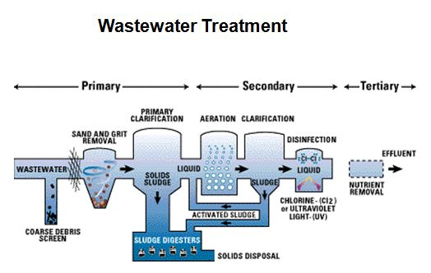

Alteration of Water Quality

Due to Loss of Oysters
Loss of oysters may seem more of an outcome of reduced water quality than a cause, but because these living organisms are such phenomenal water filters, reduction in their numbers due to over-harvesting and disease has been linked to the loss of water quality in the bay. In the 1700s, there were so many large healthy oysters in the bay that the entire body of water was filtered through oysters every 3 to 4 days. The oysters filter feed and, by so doing, they remove edible algae and inedible sediment from the water that they are filtering. Currently, with the limited numbers of oysters found in the bay and their relatively small sizes, it now takes at least a year for the water in the bay to be filtered through these organisms. There is hope that, if the oyster population can begin to increase, water quality will also be improved as this biological filter works to remove sediment, organic material, and planktonic algae from the bay.

Threats to CB: Changes of Water Quality – Consequences

Changes in Water Quality
Changes in water quality result in:
- Loss of seagrass beds
- Harmful algal blooms (HAB)
- Anoxic areas (dead zones)
- Loss of biodiversity (decline in oysters, decline in blue crabs, decline in striped bass, etc) This won't be discussed in this section, but it is a serious consequence!

Changes in Water Quality Results In:

1: Loss of Seagrass Beds
Reduction of water quality has resulted in excessive loss of submerged aquatic vegetation (SAV) in Chesapeake Bay as it has in many other parts of the world. Seagrasses are common submerged aquatic vegetation in temperate estuarine and coastal systems. These plants are critical components of many marine shallow water communities because they photosynthesize, feed waterfowl, hold sediment in place, and provide critical habitat to many crustaceans, shellfish, and small fish. They are considered indicator species because they are sensitive to environmental conditions such as water clarity and temperature and salinity changes.
Excessive nutrients that enter the bay stimulate algal growth. The algae are both planktonic and epiphyte in form. The planktonic forms block light from getting to the bottom where the grasses are growing, and the epiphytic forms of algae grow on top of the seagrasses. Other human activities such as marinas and coastal construction along with natural disturbances such as strong storms can also limit the health of these areas. In 2012, there were only 50,000 acres of submerged aquatic vegetation measured in the bay.
A goal of the Chesapeake Bay Restoration Program is to achieve 185,000 acres of SAV. Many researchers and volunteers are replanting and reseeding seagrass beds while others are striving toward the necessary improvement of water quality. In 2018, ~110,000 acres of underwater grass regions were estimated. The progress is slow but increases in health and coverage are being seen.
Optional Reading: A Massive Seagrass Project is Restoring a Lost Food Web for Wintering Geese - Audobon
Seagrass

Changes in Water Quality Results In:

2: Harmful Algal Blooms (HABs)
Excess inorganic nutrients entering into Chesapeake Bay fertilize the planktonic algae and cyanobacteria living there and, if the physical and biological conditions are favorable as well, the reproduction of these organisms increases rapidly. The resulting expansion in population size and biomass is called an algal bloom (Algae don't produce flowers!). Since these organisms are important producers, the increase in biomass should be a positive event for the community, but often these blooms are actually harmful events.
Algal blooms frequently harm the community by causing hypoxia or anoxia of the bottom water, especially in the summer when mixing is limited. The harm done by the anoxia will be discussed in the next section. However, other algal blooms are destructive because they produce and release toxins that can kill fish and sea birds, contaminate shellfish, and may even sicken fishermen and other coastal residents.
In 1997, an extensive fish kill in Chesapeake Bay was thought to be caused by the infamous dinoflagellate, Pfiesteria. Pfiesteria has been called the cell from hell because of the severe tissue damage done to the fish affected by it and because of the neurological symptoms reported by people exposed to it. However, in the past 10 years Pfiesteria hasn't proved to be a significant problem in Chesapeake Bay.
Even though "the cell from hell" hasn't been the ruin of Chesapeake Bay, algal blooms are a very serious issue. NOAA states: "Harmful algal blooms (or HABs) present one of the most scientifically complex and economically significant coastal management issues facing the nation today. In the past, only a few regions of the U.S. were affected by these harmful algal blooms, but now all U.S. coastal regions have reported major blooms. These phenomena have devastating environmental, economic (>$1 billion loss over 2 decades), and human health impacts. The Harmful Algal Bloom and Hypoxia Research and Control Act (HABHRCA) recognizes the significance of HABs and calls for research to advance scientific understanding and our ability to detect, assess, predict, control, and mitigate events."
(Source: http://www.cop.noaa.gov/stressors/extremeevents/hab/ - No longer available)
Research is currently being done that uses hydrodynamic computer models and NOAA satellite data to track the relative abundances of Karlodinium veneficum, a dinoflagellate (algae) that has contributed to several fish kills in Chesapeake Bay. The plan is for this information to lead to a more thorough understanding of the ecology of HABs and, hopefully, that will lead to the ability to predict or even prevent HABs.
Additional Information
(Not Required)
- Harmful Algal Blooms Observing System HABSOS

Changes in Water Quality Results In:

3: Anoxic Areas (Dead Zones)
Formation of hypoxic or anoxic areas (dead zones) within Chesapeake Bay is another serious result of lowered water quality. The first reading in this module covers anoxia, and the topic was also mentioned briefly in Module 3.
In the Chesapeake Bay, likelihood of formation of a dead zone and size of the dead zone once it forms is influenced by the amount of nutrients delivered, the biological response to that nutrient load, and the extent of physical mixing of the water column. Nutrient delivery is influenced by watershed activities and by the amount of water flow over and through the watershed. The biological responses are influenced by many physical, chemical, and biological conditions. The physical mixing of the water is influenced by tidal flow, wind speed, and temperatures. Excessive nitrogen delivery to the estuary is thought to be the major factor that drives formation of dead zones in Chesapeake Bay.
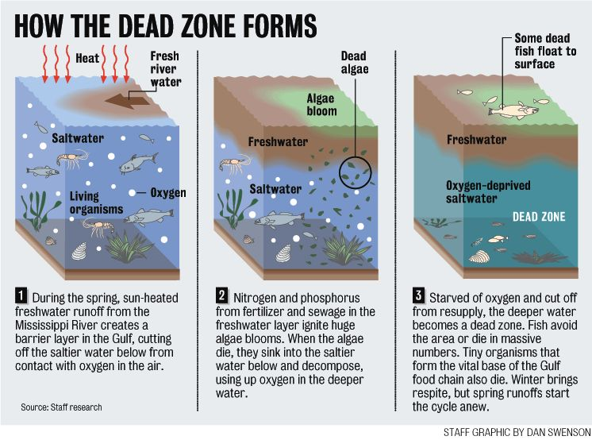
Image Credit: NOAA
In the maps shown below, nitrogen concentrations throughout the bay are shown in the spring and in the summer.
Nitrogen Concentrations in Spring
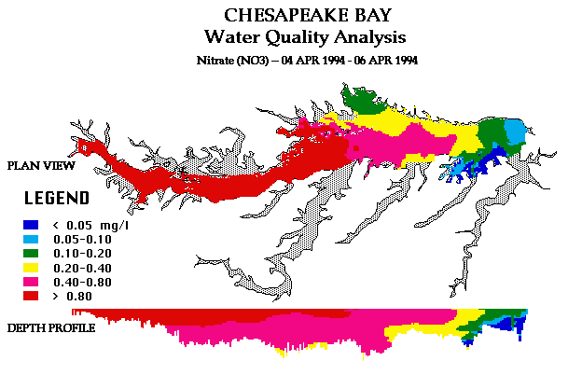
In the springtime high water flow delivers large quantities of nitrogen into the bay. The producers are just starting to grow and photosynthesize, so nutrient levels stay high for a time.
Nitrogen Concentrations in Summer
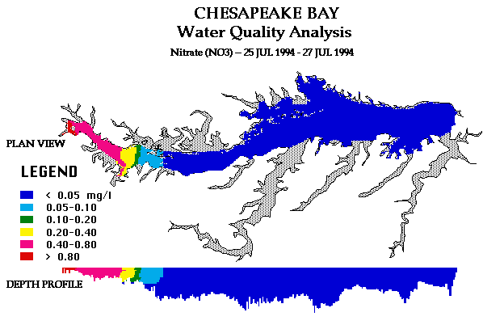
By summer, the rate of delivery has gone down (less rainfall occurring) and the growing algae have utilized the nutrients, so there's less nitrogen in the water. Yet, summertime is the time when the low oxygen zones will form.
This cycle occurs because the algae have lived and died (or been eaten) and the decomposition of that material is occurring in the sediment, which reduces the dissolved oxygen in the bottom waters. Temperature profiles of the water column keep the cold deep water at the bottom and the warm, well-oxygenated water at the top. In the image below, notice how the anoxic zones are found in deep, middle portions of the bay.
(Please note: Even though the dissolved oxygen profile (1996) was from a different year than the nitrate profiles (1994), comparisons can be made because the nutrient and oxygen depletion patterns are very similar from year to year.)
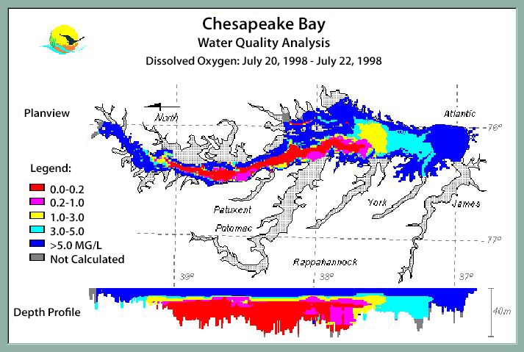
In these dead zones, very little productivity occurs. The organisms that couldn't or didn't swim away die, other species move away from these areas to live in more swallow, more oxygenated places. By consuming the oxygen, the decomposers "close off" a large portion of the bay from being fish feeding grounds, and the dead zone ends up limiting the diversity and productivity of the entire bay for that season.
Anoxic zones have increased in size and frequency and duration as the human population in the watershed has increased. There is a strong positive correlation between nutrient pollution and dead zone formation. It is hoped that, as water quality improves, the occurrence of dead zones within the bay will become less frequent and the aquatic community will respond with increased production and diversity.

Threats to CB: Impacts of Global Climate Change
The major threats to the Chesapeake Bay that are associated with global climate change are 1) the rise in sea level that is expected; 2) the possibility of more frequent, more intense storms; and 3) the actual increase in temperature of the air and water.
Sea level is already increasing due to thermal expansion of the water and to glacier and ice cap melting. Many coastal areas worldwide are experiencing changes due to this increase. With sea level rise in Chesapeake Bay, the risks are primarily involved with habitat loss. The risks include loss of marshland that is limited already, reduction in health and functional ability of the submerged aquatic vegetation, and alteration of the salinity within many areas of the bay. Two of the major diseases of Chesapeake Bay oysters (Dermo and MSX) are caused by parasites that are much more virulent at higher salinities. This could mean loss of restored oyster beds if the salinity around them is altered by a significant influx of saltwater into the bay caused by sea level rise.
If global climate change brings more intense and more frequent storms to Chesapeake Bay, long lasting effects of these natural "assaults" will be seen. Large amounts of erosion occur during intense storms, which can lead to habitat loss and reduction in water clarity. Much of the precipitation that occurs throughout the watershed during major storms rushes into the bay within days or hours after the start of such a storm. This water flushes the land of fertilizers, pesticides, pollutants, organic material, and sediments that end up in the bay's water. This delivery can cause massive reductions in salinity and alter other chemical and physical properties so rapidly that many organisms don't have time to acclimate (adjust) to the changes. If the changes don't kill the organisms right away, they can cause stress that weakens the organism and makes them more susceptible to disease and other stressors. Storm surges bring tidal flow farther into the estuary than is normal and this also alters the salinity.
In this area, warmer temperatures and greater precipitation are expected with continued rise in atmospheric CO2. The increase in temperature of the air and water of Chesapeake Bay may bring detrimental changes, including increases in disease and HABs, larger and longer lasting dead zones, and changes in distributions of organisms. The warmer temperatures will stress the organisms that are living at the upper limits of their temperature tolerances, and this physiological stress may leave the organisms more susceptible to disease. Incidence of harmful algal blooms (HABs) is also predicted to rise as temperatures increase. With warmer temperature, rates of photosynthesis, biomass production, and rates of decomposition increase as well. Therefore, with more organic material produced and more decomposition occurring, oxygen levels will be more extensively depleted. The dead zones of the previous summers were already too large to have a healthy, fully functional estuarine system and, unfortunately, the increase in temperature and precipitation predicted with further climate change should limit rates of mixing, should increase oxygen demand, and should only cause conditions to worsen.
Distribution of organisms all over the world will change with climate change. Even though aquatic environments experience less temperature fluctuations than do land environments, it is expected that some organisms within Chesapeake Bay will shift habitats (e.g., some species of fish will move to colder, deeper water), some will migrate to other ecosystems, and some will die out. In addition, other species are expected invade the area. So, to state it simply, it is predicted that community structure and ecosystem function will change with climate change within the Chesapeake Bay.
Additional Information
An excellent source of information on this topic is The Changing Chesapeake (Not Required)

Module 5 Reading Assignment 2
Description:
You have two reading assignments for Module 5. This is the second one. A link for the reading is given below along with a set of reading goals that will help define the important issues in the reading. Submissions of answers to the questions are not required.
Instructions:
Click on the link shown below to learn about the state of the Chesapeake Bay in 2020.
The 2020 State of the Bay report.
Note: No submission is required for this assignment! These goals are for you to use to guide your analysis and learning from the article.
Reading Goals:
- In 2020 what was the average health index score of the bay? ______pts out of 100
  - Summarize what happened to the Bay in 2020.
  - The "goal" score for the Bay is 70 (Chesapeake Bay Foundation's Mission)
- Pollution, Habitat and Fisheries are the 3 major categories for the indicators of bay health.
  - Review the indicator points within each category and how they have changed in the last two years (2018 - 2020).
3. Briefly explain the purpose of the Making History Campaign.

Summary
The Chesapeake Bay is a national treasure. Its landscapes are spectacular, and its functions are life-supporting. It is economically critical and it is extremely ecologically and biologically diverse. An ecosystem as immense and as diverse as the Chesapeake Bay has a tremendous amount of complexity and resiliency. The bacteria decompose the wastes, the water mitigates climatic changes, the forests and marshes remove pollutants, and the oysters clarify (or used to be able to clarify) the water. However, the stresses caused primarily by the growth of the human population in the area and globally have taken their toll on the health of the bay and many bays and estuaries like it around the world. Many individuals – politicians and conservationists, grandmothers and CEOs, are working toward saving the bay. This is the right thing to do; it is the only thing to do – no matter how discouraging the lack of progress and set backs might be, no matter how expensive it turns out to be, no matter how much resistance there is to the work, it must be tried. Our children and their children require and deserve a functioning, healthy Chesapeake Bay. With scientific study and community resolve, the Chesapeake Bay can and will be healed.

